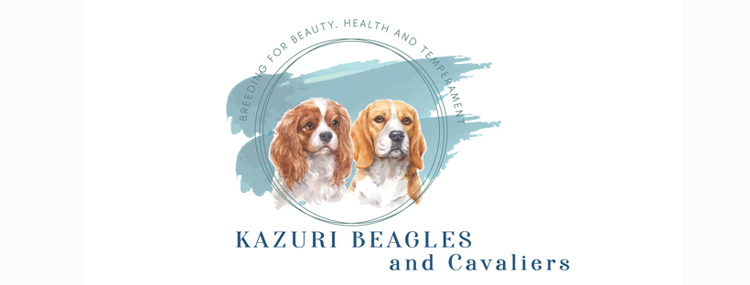
Deposit Contract
Client Name:______________________________________________ Reservation Date:________________
Address:_________________________________________________________________________________
Phone:____________________ Email:_______________________________
Preferred Gender/Color:____________________________________________
Kazuri Beagles and Cavaliers requires a non-refundable deposit of $50.00 (USD) to be placed on our waiting list for a Beagle or Cavalier King Charles puppy. All of our puppies come to you micro-chipped, wormed for parasites, first vaccination and a wellness puppy examination by a Veterinarian. By the form of a signature below, the client named above indicates their agreement and understanding to the following:
- Waiting list positions are secured by a non-refundable $50.00 deposit. This deposit will be applied to the total purchase price of your puppy. Make checks payable to Sarah Sweetman and mailed to 18046 160th place NE, Woodinville WA 98072. Venmo is also accepted - @sarah-sweetman-photo
- All wait list reservations are in order of receipt of this form and deposit.
- Wait list deposits are non-refundable with no exceptions.
- You are most welcome to change your preference of gender or color and we will make every effort to accommodate that change but understand we cannot bump other clients that have reservations already in place. If you are flexible on color/gender please indicate that at time of reservation
- We will notify you within four weeks of the litter being born as to availability and of approximate puppy go home date.
- Once the litter is born and your preference of color/gender is confirmed you are requested to make an additional minimum deposit of $350.00 to reserve your puppy. Payment will be applied to the purchase price.
- You may withdraw your reservation for a full refund (less the non-refundable wait list deposit) up until the litter is 6 weeks of age. If you withdraw your reservation for whatever reason after the litter is 6 weeks old, all but $100.00 of your deposit will be refunded. Please be thoughtful in your decision to reserve a puppy. The refundable portion will be returned to you once the puppy has been placed with a new family.
- The balance due on your puppy is to be paid by the time the litter is 8 weeks of age or when you pick up your puppy, whichever comes first. Cash if preferred for final payment.
- No puppy or dog will leave the premises without being paid in full.
- You are welcome to visit the litter by appointment only.
- We ask that you plan to pick up your Beagle puppy on or around 8 weeks and your Cavalier King Charles puppy from 10-12 weeks in person. Please make arrangements for this time frame. We do not ship puppies.

______________________________________________________ ______________________________
Client signature Date

